
Department of Mechanical Engineering

EMCH 368
MECHATRONICS

Lab 10
PID Controller

Last Edited: 10/19/2022 by K. Bhanuprakash

Simulink is a program within MATLAB that features a graphical programming environment developed by MathWorks. It is used for modeling, simulating, and analyzing multi domain dynamical systems using block libraries which we will explore.

Accessing the Simulink / Arduino interface
As mentioned in the previous lab, Simulink can be used in conjunction with Arduino to collect data and issue commands accordingly. The goal of this lab is to create a control circuit using Arduino to issue commands to Simulink, which is then used to tune the gains of a PID controller
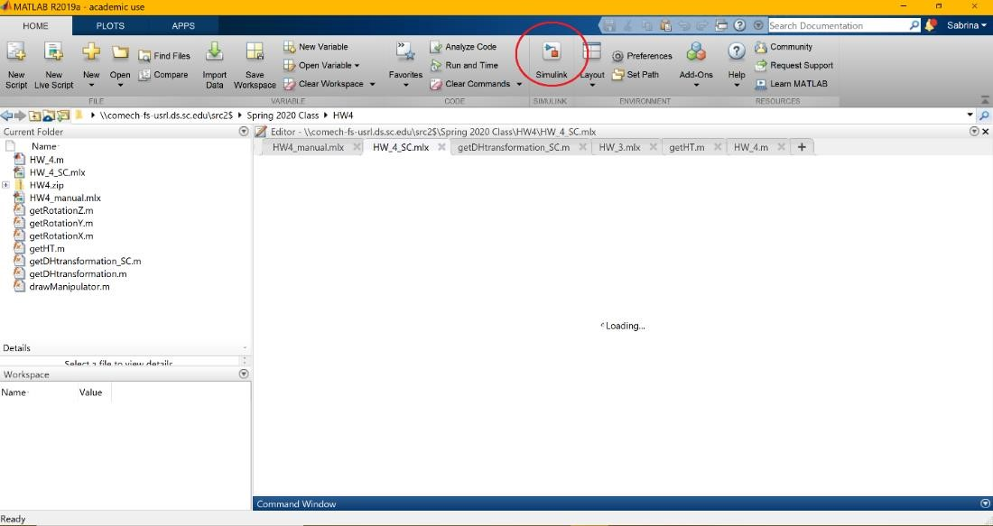

Background
- Constant Block: used to input constants into simulation.
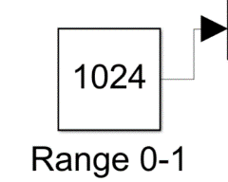
- Manual Switch: used to flip between two inputs.
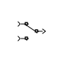
- Contineous pulse generator: functions as the ideal input signal.
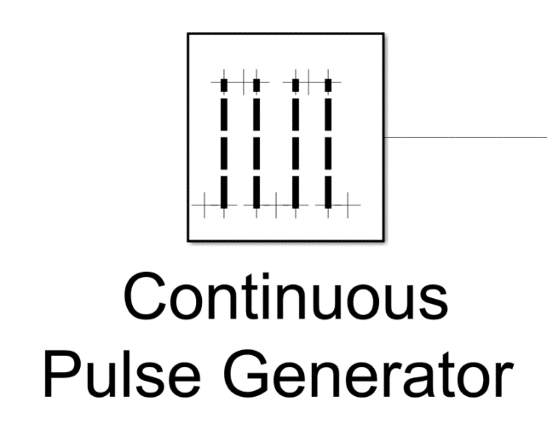
- Switched Derivative for Linearization: Derives a given input.
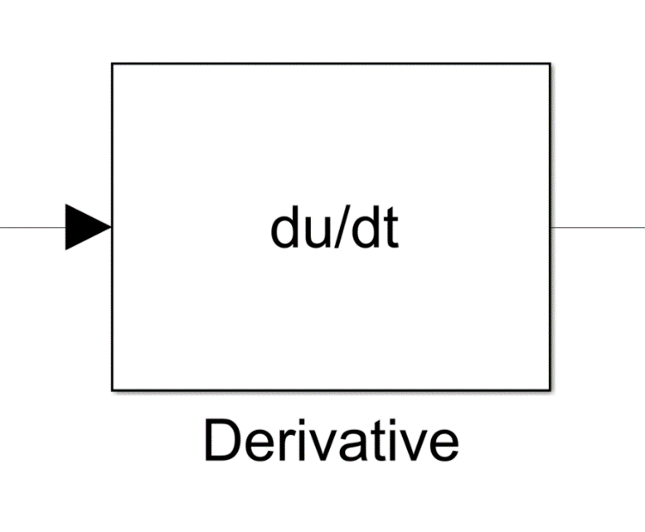
- Integrator: Integrates a given input.
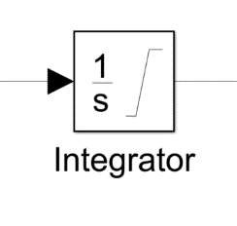
- Product: Multiply two given inputs.
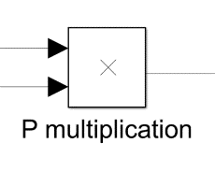
- Divide: Divides a given input 1 by input 2.
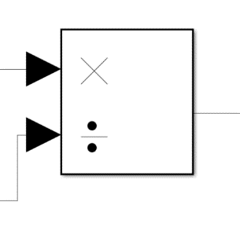
- Sum: Used to add or subtract two or more inputs.
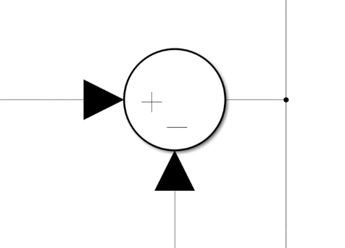
- Display: Indicates input numerically.
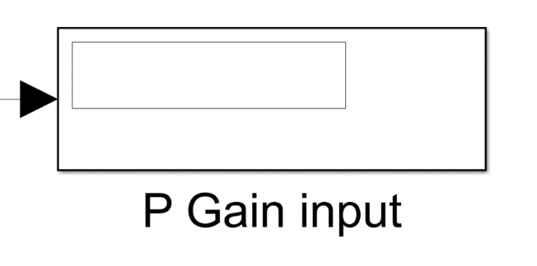
- Scope: Indicates inputs graphically.
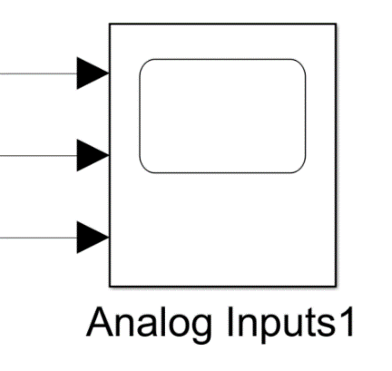
- Transfer Fcn: transfer function used to manipulate a given input
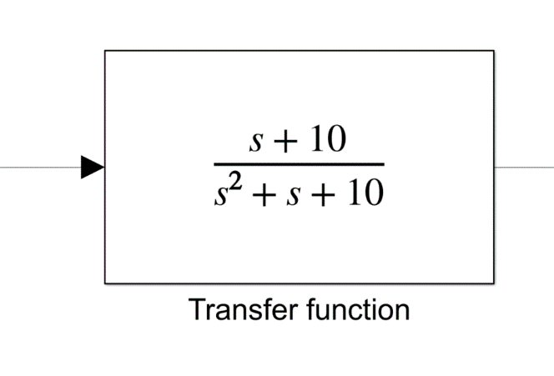
- Step: Ideal step function (used to indicate error).
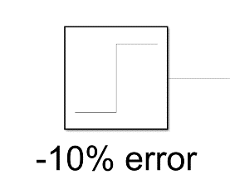

Graded Assignments
In this lab there are three projects:
- Project 1 – Constant input
- Project 2 – PID controller
For grading purposes, you will present the scopes from the two different projects either in-person or online during your specified lab session.

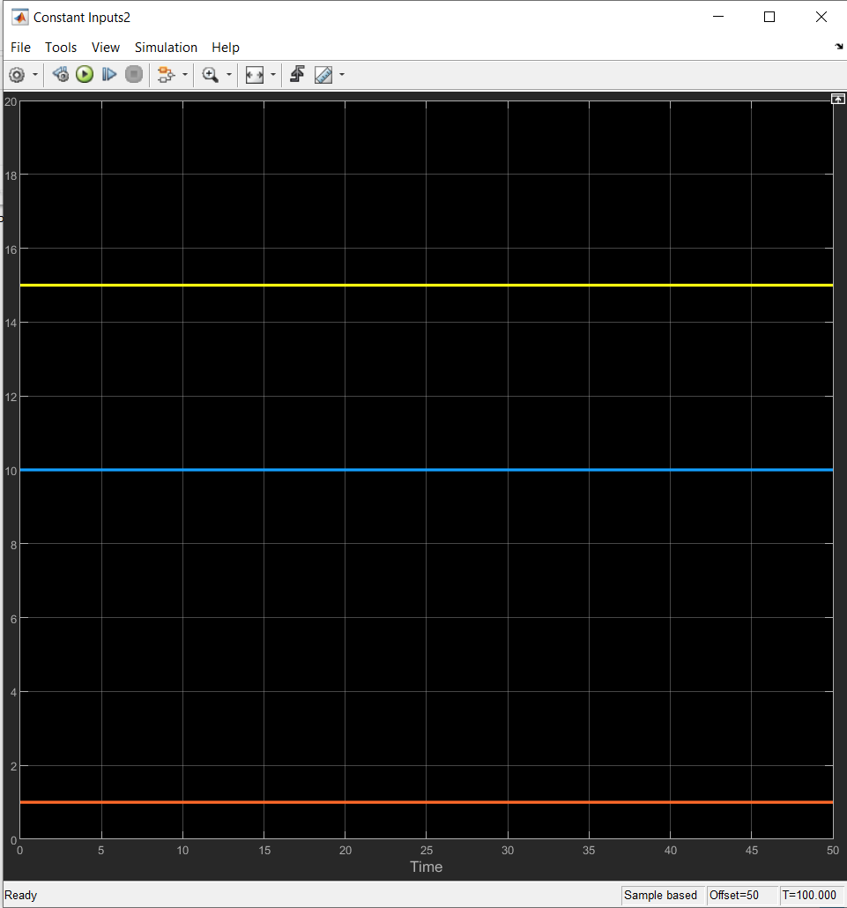
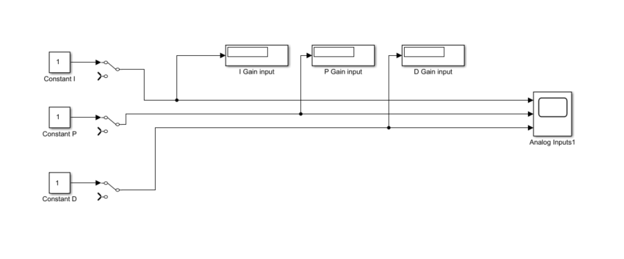
Project 1: Constant input: the constant inputs should appear in the display and scope.
Project 2: PID Controller:
- Build the Simulink circuit as below
- Utilize the switches to connect back to the constant blocks of the PID gains.
- Iterate using the constant blocks to find gains that allow for a ±10% error.
- Switch to analog read and match your gains using the potentiometers.
- Indicate that your signal is within ±10% error using the scope.
- Use the table below to guide you through the tuning process.

Parameters | Rise-time | Overshoot | Settling time | Steady state  error | Stability
Kp | Decrease | Increases | Small change | Decrease | Increase
Ki | Decrease | Increases | Increases | Eliminates | Increase
Kd | Small change | Decrease | Decrease | No effect | Decrease

Note:
- Select Pulse type: Time based, and use simulation time set, Amplitude: 100, Period(secs): 10, Pulse Width: 50.
- Since the Amplitude here is 100, ±10% error means Final values in the block parameters should be 110 or 90 and Step Time: 0
- Start with initial gains as Kp: 12, Ki: 80, Kd:0.8 fine tune following the table
- How to use the Table for tuning:
For example, here overshoot is high, you need to decrease it so look at the table under Overshoot: Decrease, along the horizontal it points to Parameter Kd. So, adjust Kd gain repeat the process till you get a satisfactory value.
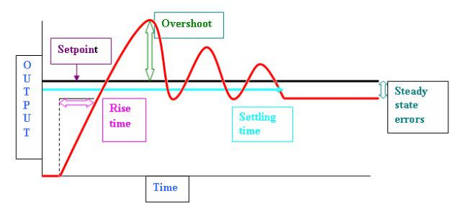
Figure 1: PID Terminology [4]

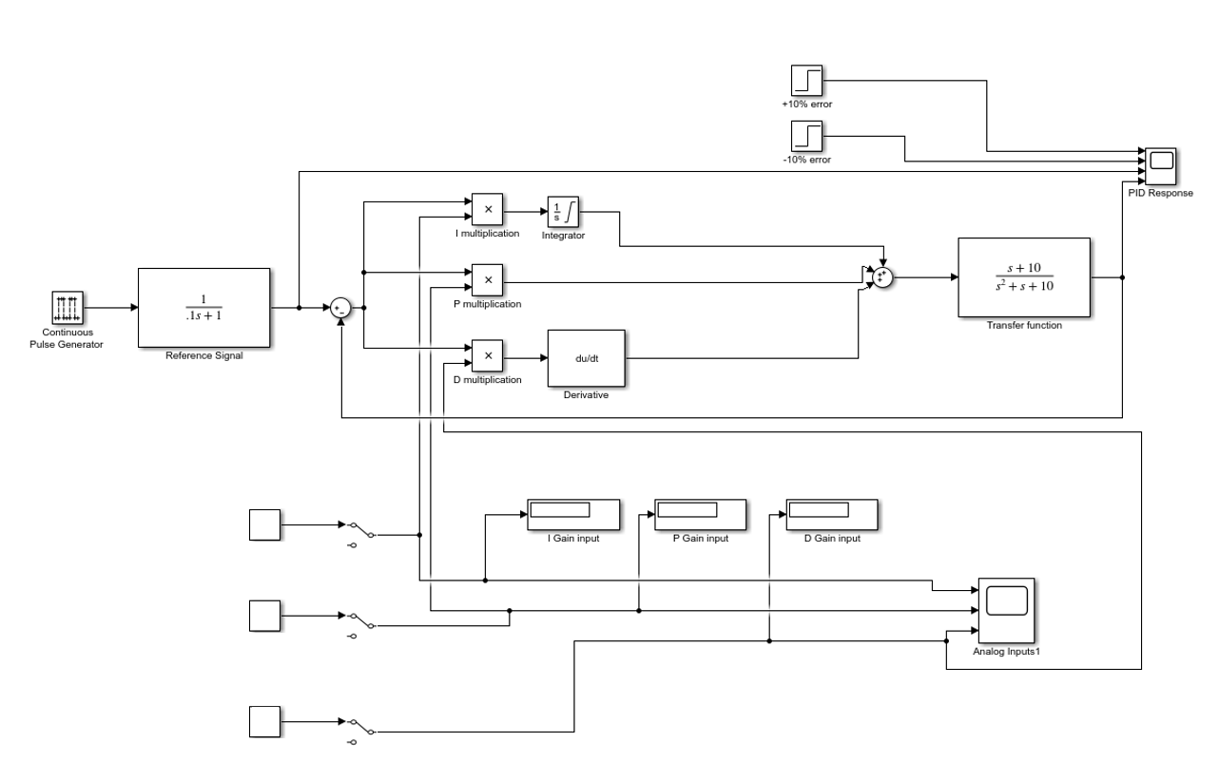
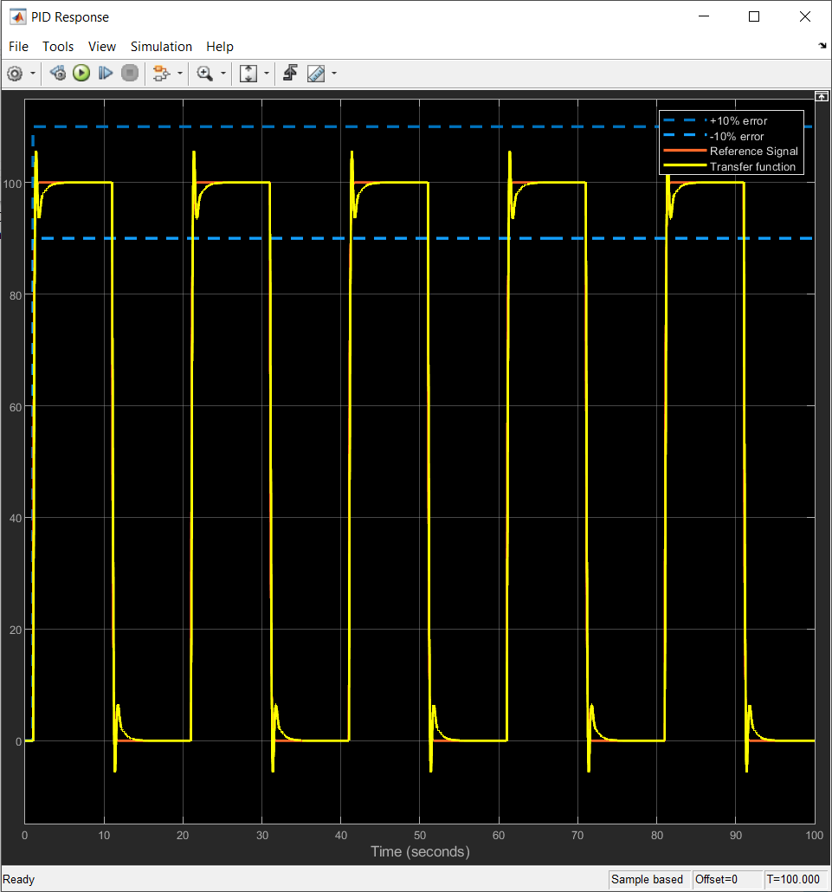

Hints:
- When tuning PID Start small and climb your way up in gain, start by proportional, integration, and finally the derivative gain as it’s the one with the most instability.
- When tuning the PID gains, use constants at first to prevent the signal from going uncontrollably unstable, then utilize the switches to use the analog read inputs later on
- If the simulation glitches or crashes that means your gains are too unstable.
- Consider adjusting the sampling rates of analog read, scope, simulation for a clear waveform.
- Use display settings of your scope to make your graph lines thicker and different colors.

Helpful Links:
- https://www.mathworks.com/hardware-support/arduino-simulink.html
- https://www.mathworks.com/videos/programming-arduino-uno-with-simulink-86316.html
- https://www.youtube.com/watch?v=nOz3uTi20Jo
- https://medium.com/autonomous-robotics/pid-control-85596db59f35

Lab 10 Grading Rubric:
- Project 1 (Constant input) complete with accurate scope (20 points)
- Project 2 (PID Controller) complete with accurate scope (20 points)
- Adequately answer questions regarding the two projects (10 points)
Grade distribution template (total 50 points)

